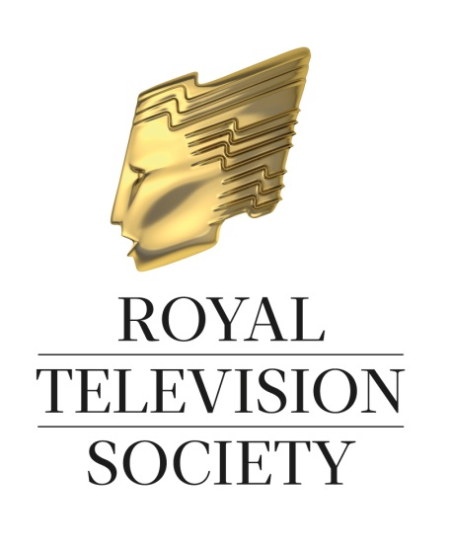
RTS Student
Programme Masterclasses

Monday 27 October 2014

BFI Southbank, Belvedere Road, London, SE1 8XT

On Monday 27 October, the RTS will be holding a series of Student Programme Masterclasses. Three Masterclasses will cover Comedy, Factual and Drama providing the opportunity to hear from respected industry professionals.

Speaking at the Comedy Masterclass will be Saurabh Kakkar, Head of Comedy Development at Big Talk Productions who has spent his career developing and producing comedy for a broad spectrum of channels, including programmes such as Dirk Gently, The Fattest Man in Britain, Headcases and Stan and Ollie.

The Factual Masterclass will feature Andrew Mackenzie, Creative Director at Twofour Group responsible for a host of critically acclaimed series across all the major UK Broadcasters, including Educating Yorkshire, Graffiti Wars, My Big Fat Gypsy Wedding and Splash!.

Lastly, Gwyneth Hughes will be speaking during the Drama Masterclass. Gwyneth is an award winning screenwriter, recently winning the Writers Guild Award for The Girl whose work has been screened across all the major channels, including Five Days, Miss Austen Regrets and Cherished.

A draft timetable for the day can be found at the end of this document, and further details will appear on www.rts.org.uk when available.

HOW TO BOOK:

- These Masterclasses are open to all students and tutors attending academic institutions
- Tickets can be booked either by the University or individual students
- There is no limit as to how many tickets can be booked
- Tickets are free of charge but a booking form must be completed for each booking

To book, please complete and return the form on the following page to Jamie O’Neill at Jamie@rts.org.uk. Or contact Jamie on 020 7822 2821.

RTS Student Programme Masterclasses
Booking Form

CONTACT NAME:

UNIVERSITY:

NUMBER OF TICKETS REQUIRED : ………

ADDRESS 1:

ADDRESS 2:

CITY:

COUNTY:

POSTCODE:

TELEPHONE:

E-MAIL:

PLEASE LIST ALL ATTENDEE NAMES BELOW :

RTS Student Programme Masterclasses
Monday 27 October 2014

SCHEDULE
(subject to amendment)

10.30am Registration opens
Complimentary Tea, Coffee and Biscuits

11.00am Introduction

11.00am – 12.15pm Masterclass 1 – Comedy
Speaker: Saurabh Kakkar, Head of Comedy Development, Big Talk Productions

12.15pm – 1.00pm Lunch

1.00pm – 2.15pm Masterclass 2 – Factual
Speaker: Andrew Mackenzie, Creative Director, Twofour Group

2.15pm – 2.45pm Tea / Coffee Break

2.45pm – 4.00pm Masterclass 3 – Drama
Speaker: Gwyneth Hughes

4.00pm Closing

4.00pm – 5.00pm Drinks Reception and Cash Bar

5.00pm End of Day

Please visit www.rts.org.uk for further information

Follow us on Twitter @RTS_media and #RTSStudent

