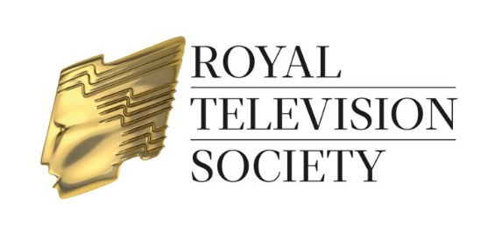

RTS Television Journalism Awards Dinner 2018
Sponsored by GuestBooker

The RTS Television Journalism Awards 2018 will be presented at an Awards Dinner on Wednesday 28 February 2018 at 7.00pm for 7.30pm, at the London Hilton, Park Lane, London W1K 1BE. The Awards will be hosted by Reeta Chakrabarti. Dress code – Black Tie.

Please complete all sections of the form

Option 1
Full Table EXCLUDING Wine:
Please reserve ................. table(s) for 12 persons at £2,880.00 (+ £576.00 VAT)

Option 2
Full Table INCLUDING ½ bottle of wine per person:
Please reserve ................. table(s) for 12 persons at £3,120.00 (+ £624.00 VAT)

Option 3
INDIVIDUAL TICKET PRICE (ticket price includes ½ bottle of wine per person):
Please send me .............. ticket(s) at £260.00 (+ £52.00 VAT) per person

Name of Host of each table ..........................................................................................
(It is most important to provide this name when making your booking)

Contact Name .....................................………………………………………………….….

Tel No. ................................……………………………………………………………..…

E-mail ………………………………………………………………………………….……...

Company ..................................................................................................................….

Address ..............................................................................................................………

............................................................................................Postcode.........................

IMPORTANT: please see next page for booking details

No refunds will be made for cancellations after Friday 16 February 2018. Refunds made prior to this date will be subject to a 10% administration charge.

RTS Television Journalism Awards Dinner 2018

Booking information

- Options 2 & 3: tickets are £260.00 (+ £52.00 VAT) per person and are inclusive of service and ½ bottle of wine per person.
- Option 1: a table of 12 is £2,880.00 (+ £576.00 VAT) this ticket price excludes wine – a wine list and order form will be forwarded together with your tickets.
- All cheques should be made payable to RTS Enterprises Ltd. A VAT receipt will be issued on receipt of payment. Credit card payments cannot be accepted for this event. Purchase orders should be made out to RTS Enterprises Ltd. Please ensure a hard copy of your purchase order is supplied with your registration form to enable us to check that the payment details are correct.
- Bookings are not confirmed and tickets will not be dispatched until payment has been received.
- No refunds will be made for cancellations after Friday 16 February 2018. Refunds made prior to this date will be subject to a 10% administration charge.
- If it is possible at this time to let us have the names of your guests please attach a list of their names on a separate sheet (including first names for the guest list and place cards).
- Please inform the RTS Events Department of any special dietary requirements on behalf of your guests. The RTS cannot guarantee to accommodate special requests unless notified by Wednesday 21 February 2018.

Return this form to:
Jamie O’Neill, Events Department, Royal Television Society, 3 Dorset Rise, London EC4Y 8EN. Tel: 020 7822 2821 E-mail: jamie@rts.org.uk

Follow us on @RTS_media and keep up-to-date with news about the RTS Television Journalism Awards at #RTSAwards

