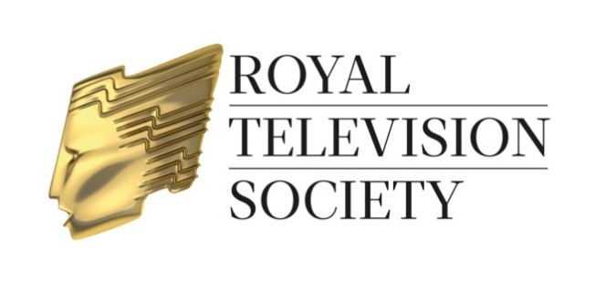

Craft & Design Awards Dinner 2017

Presentation Hosted by Iain Stirling

The RTS Craft & Design Awards for 2017 will be presented at an Awards Dinner on Monday 27 November 2017 at 7.00pm for 7.30pm, at the London Hilton, Park Lane, London, W1K 1BE. Dress is formal – Black Tie.
Please complete all sections of the form

Option 1
Full table EXCLUDING wine:
Please reserve ................. table(s) for 10 persons at £2,380.00 (+ £476.00 VAT)

Option 2
Full table INCLUDING ½ bottle of wine per person:
Please reserve ................. table(s) for 10 persons at £2,580.00 (+ £516.00 VAT)

Option 3
Individual ticket price (ticket price includes ½ bottle of wine per person:
Please send me .............. ticket(s) at £258.00 (+ £51.60 VAT) per person

Name of Host of each table ..........................................................................................
(It is most important to provide this name when making your booking)

Contact Name .....................................………………………………………………….….

Tel No. ................................…………………Fax No. ……………………….………….

E-mail ………………………………………………………………………………….……...

Company ..................................................................................................................….

Address ..............................................................................................................………

............................................................................................Post Code.........................

IMPORTANT: please see next page for booking details

No refunds will be made for cancellations after Friday 10 November 2017. Refunds made prior to this date will be subject to a 10% administration charge.

Craft & Design Awards Dinner 2017

Booking information

- Options 2 & 3: tickets are £258.00 (+ £51.60 VAT) per person and are inclusive of service and ½ bottle of wine per person
- Option 1: a table of 10 is £2,380.00 (+ £476.00 VAT) and is inclusive of service but excluding wine – a wine list and order form will be forwarded together with your tickets.
- Purchase orders should be made out to RTS Enterprises Ltd. Please ensure a hard copy of your purchase order is supplied with your booking to enable us to check that the payment details are correct. Should you wish to pay by bank transfer, an invoice will be issued on receipt of your booking which will include details on how to make payment. Cheques should be made payable to RTS Enterprises Ltd. A VAT receipt will be issued on receipt of payment. Credit card payments cannot be accepted for this event.
- Bookings are not confirmed and tickets will not be dispatched until payment has been received.
- No refunds will be made for cancellations after Friday 10 November 2017. Refunds made prior to this date will be subject to a 10% administration charge.
- If it is possible at this time to let us have the names of your guests please attach a list of their names on a separate sheet (including first names for the guest list and place cards).
- Please inform the RTS Events Department of any special dietary requirements on behalf of your guests. The RTS cannot guarantee to accommodate special requests unless notified by 22 November 2017.

Please return your booking form to:

Alice Turner - Tel: 020 7822 2822 E-mail: aturner@rts.org.uk
Royal Television Society, 3 Dorset Rise, London EC4Y 8EN.

Follow us on @RTS_media
#RTSAwards

